|  |
| --- |
| Cyber Defenders |
| CaseVegas |
| Threat Intelligence |

|  |
| --- |
| Abdallah Chbaro  09/04/2023 |

# Scenario

You are a detective, and you have been instructed to find a suspect who was employed in a major hotel chain and was responsible for the theft of US$ 3.5 million from his employers.

When you were given the instruction, you were busy with another investigation and immediately abandoned that to start this new investigation. You were also meant to be home hours ago to take your loved one to a nice restaurant for a well-deserved dinner and relaxation time.

During the investigation, your attempt to find the suspect was recorded in the included video. Analyze the video and other files and try to extract answers for some of the case questions.

# Tools

* Google maps
* Phone Lookup
* Earth Cam

# Write Up

A simple google search will make us answer the 5th question, about the date of the Mandalay shooting:

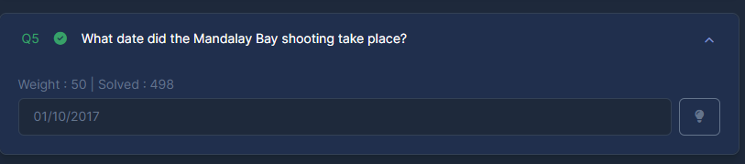

The vehicle appeared in the video at the 35th minute:

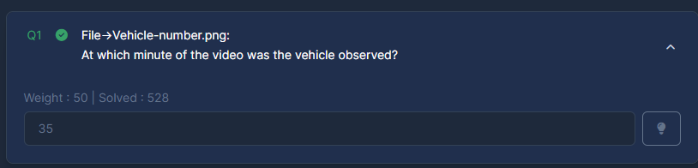

We see a name of a street in the video directly after catching the vehicle. It is called Stewart Avenue. Doing a simple google search on Stewart Avenue in Las Vegas, we get the zip code:

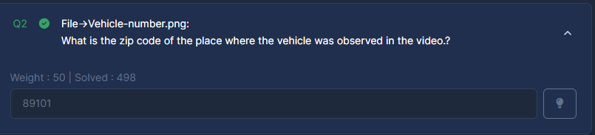

In the last 10 minutes of the video, we can see the Chapel:

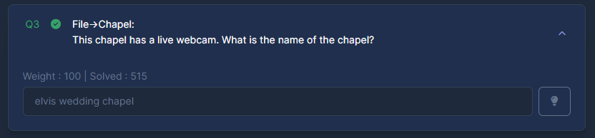

We can see ‘The Strat’ infront of the chapel.

Doing a google search, we can find the CCTV footage:

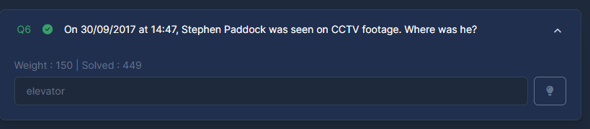

This question is related to another vehicle, present in the folder. We can see it in the video, a white SUV:

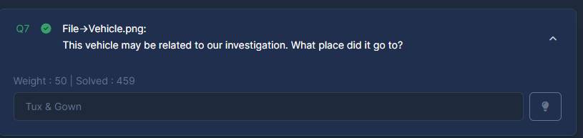

The next is a simple google search with a ‘PDF’ as google dork:

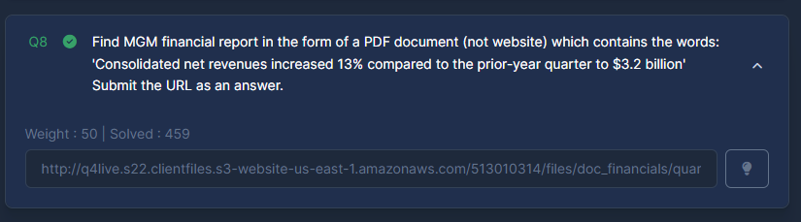

Next, there is a phone number in the folder, that is incomplete. We find the footage in the video and then doing a google search on the street number shown in the video, we can find the complete number:

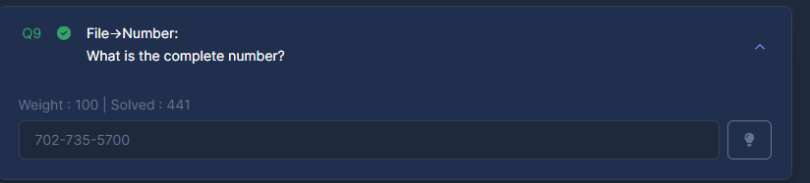

Next, we put the found number on callcenter.com and we find the owner:

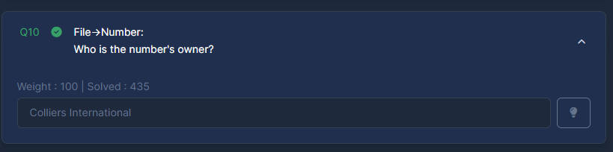The following question, with a google search, shows that it is a Hotel in Las Vegas:

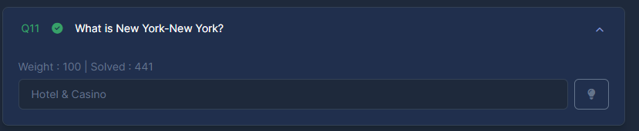

A google search will reveal the names of the speakers:

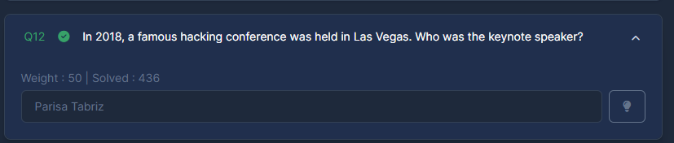

As for the tower, this photo is also present in the video. We can see the name of the tower if The Ogden:

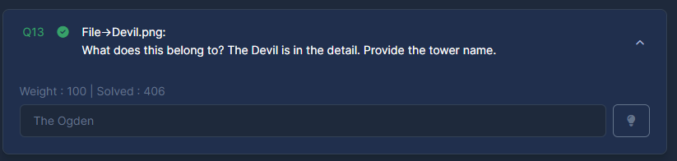

It was shown in the video at minute 34:

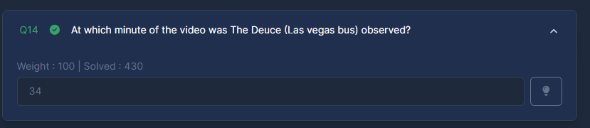

Next, it also appears in the video:

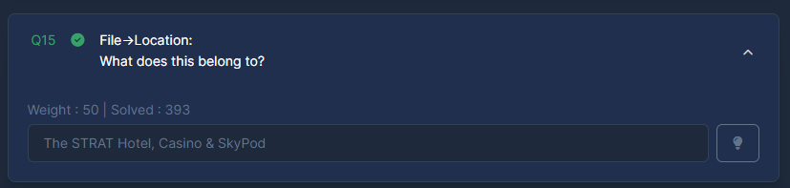

We can use the coordinates to search on google maps, and then relate to the video:

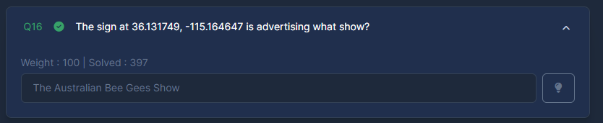

The person in the next question was seen at the 11th minute:

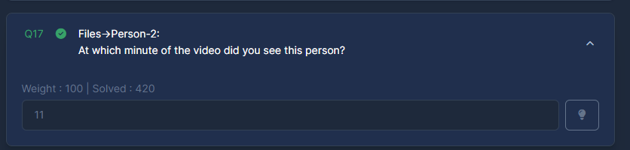

In the last question, we can visit facebook and providing the ID. It will land on the Mob Museum